Lab 9: Disassembling C on Windows
Course Name: Malware Analysis and Reverse Engineering (IAM302)
Student Name: Nguyễn Trần Vinh – SE160258
Instructor Name: Mai Hoàng Đỉnh
Lab Due Date: 15/2/2023

Purpose
You will write a small C programs, compile it, and examine it in the IDA Pro disassembler to learn what it looks like in assembly language.

What You Need
- A Windows machine, real or virtual. I used Windows 8.
- Visual Studio Express, which you installed in a previous project.
- IDA Pro Free, which you installed in a previous project.

Starting Visual Studio Express
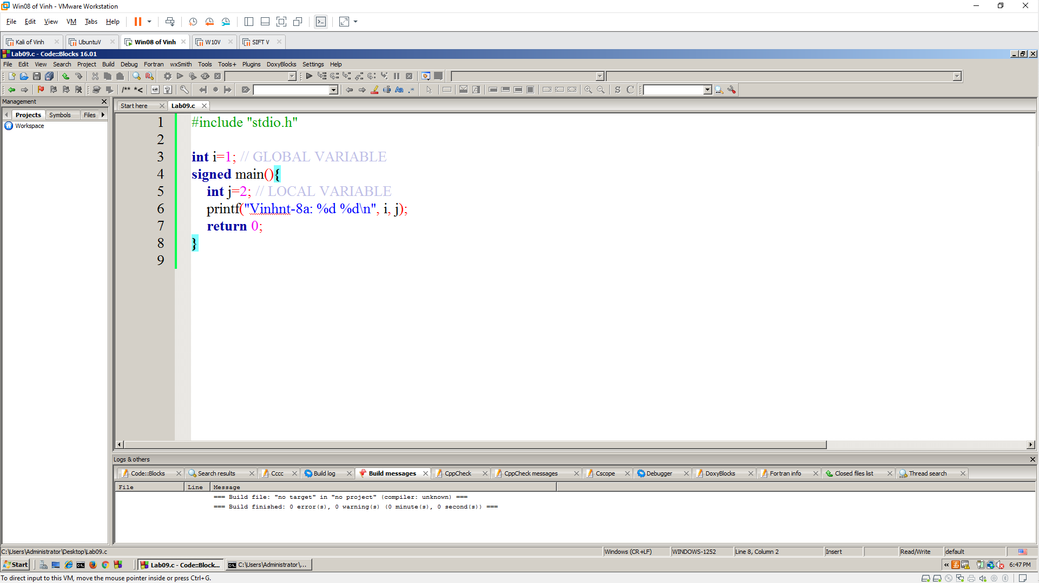

Build and Run
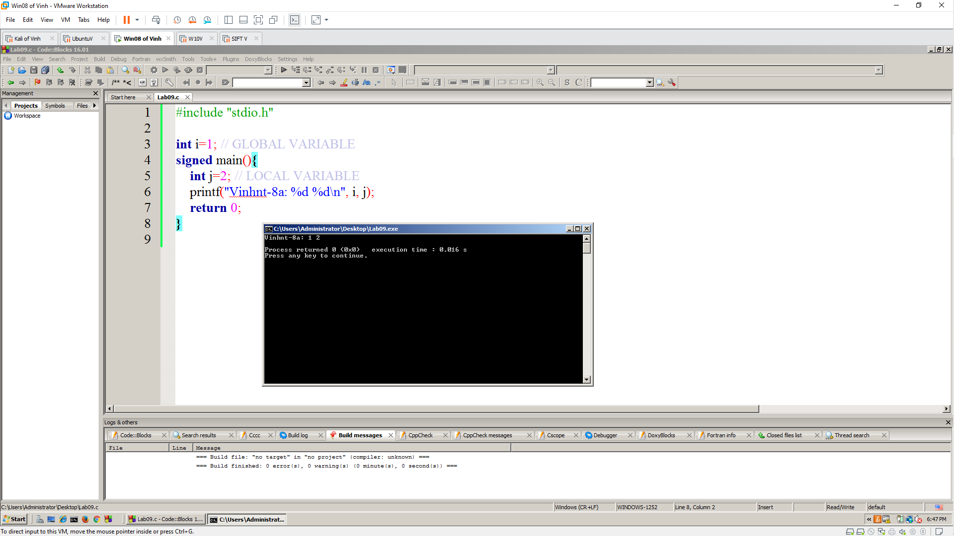

Disassembling the EXE
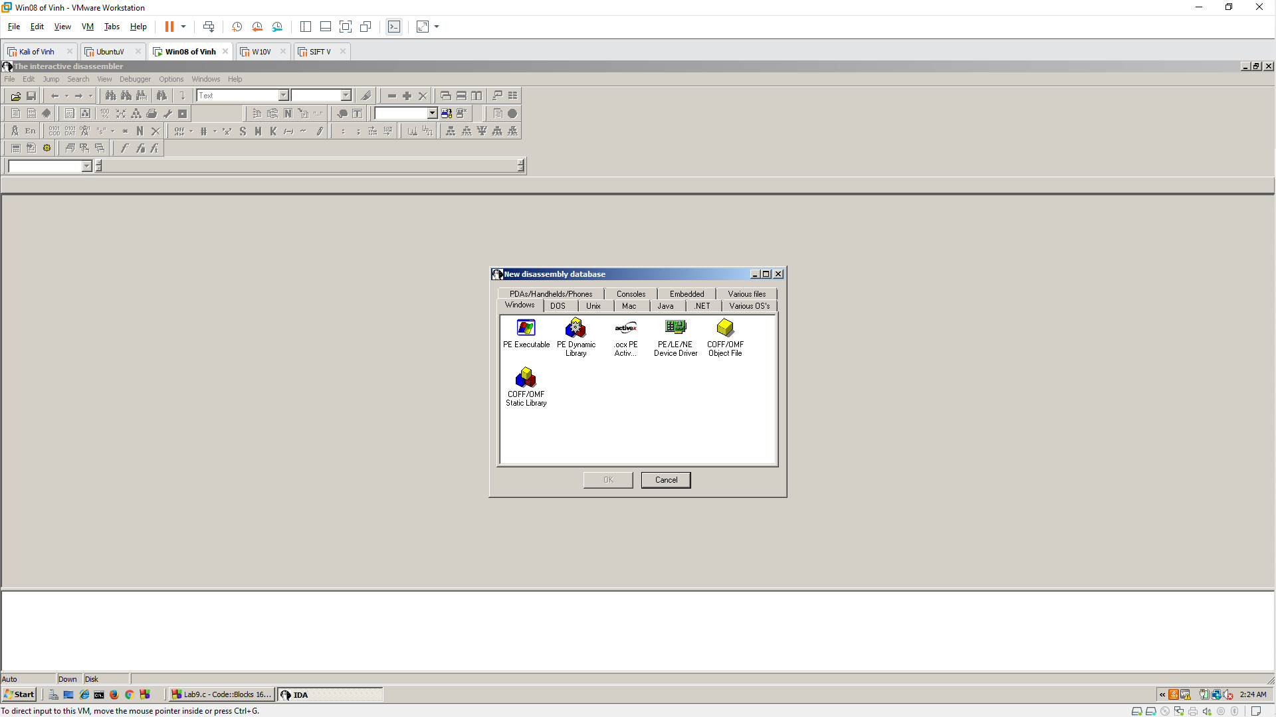
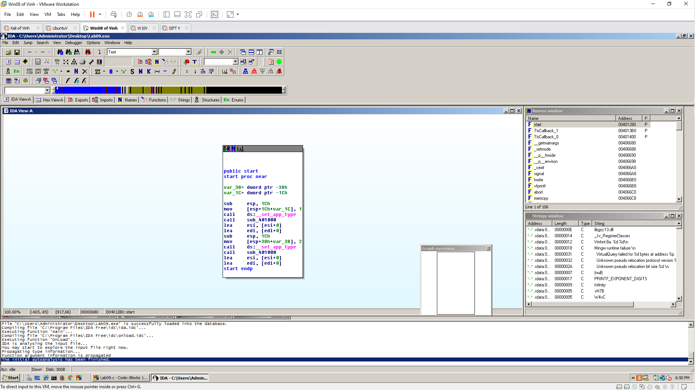

Strings window
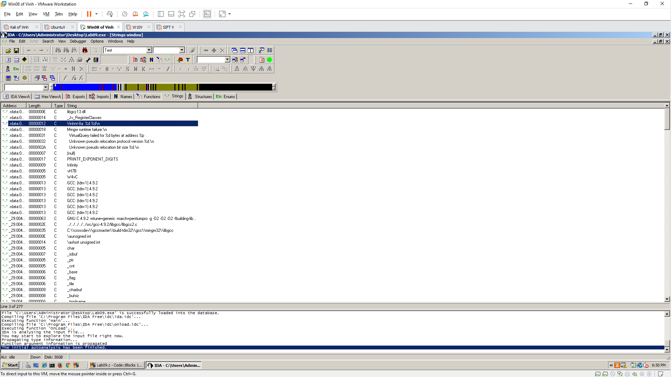
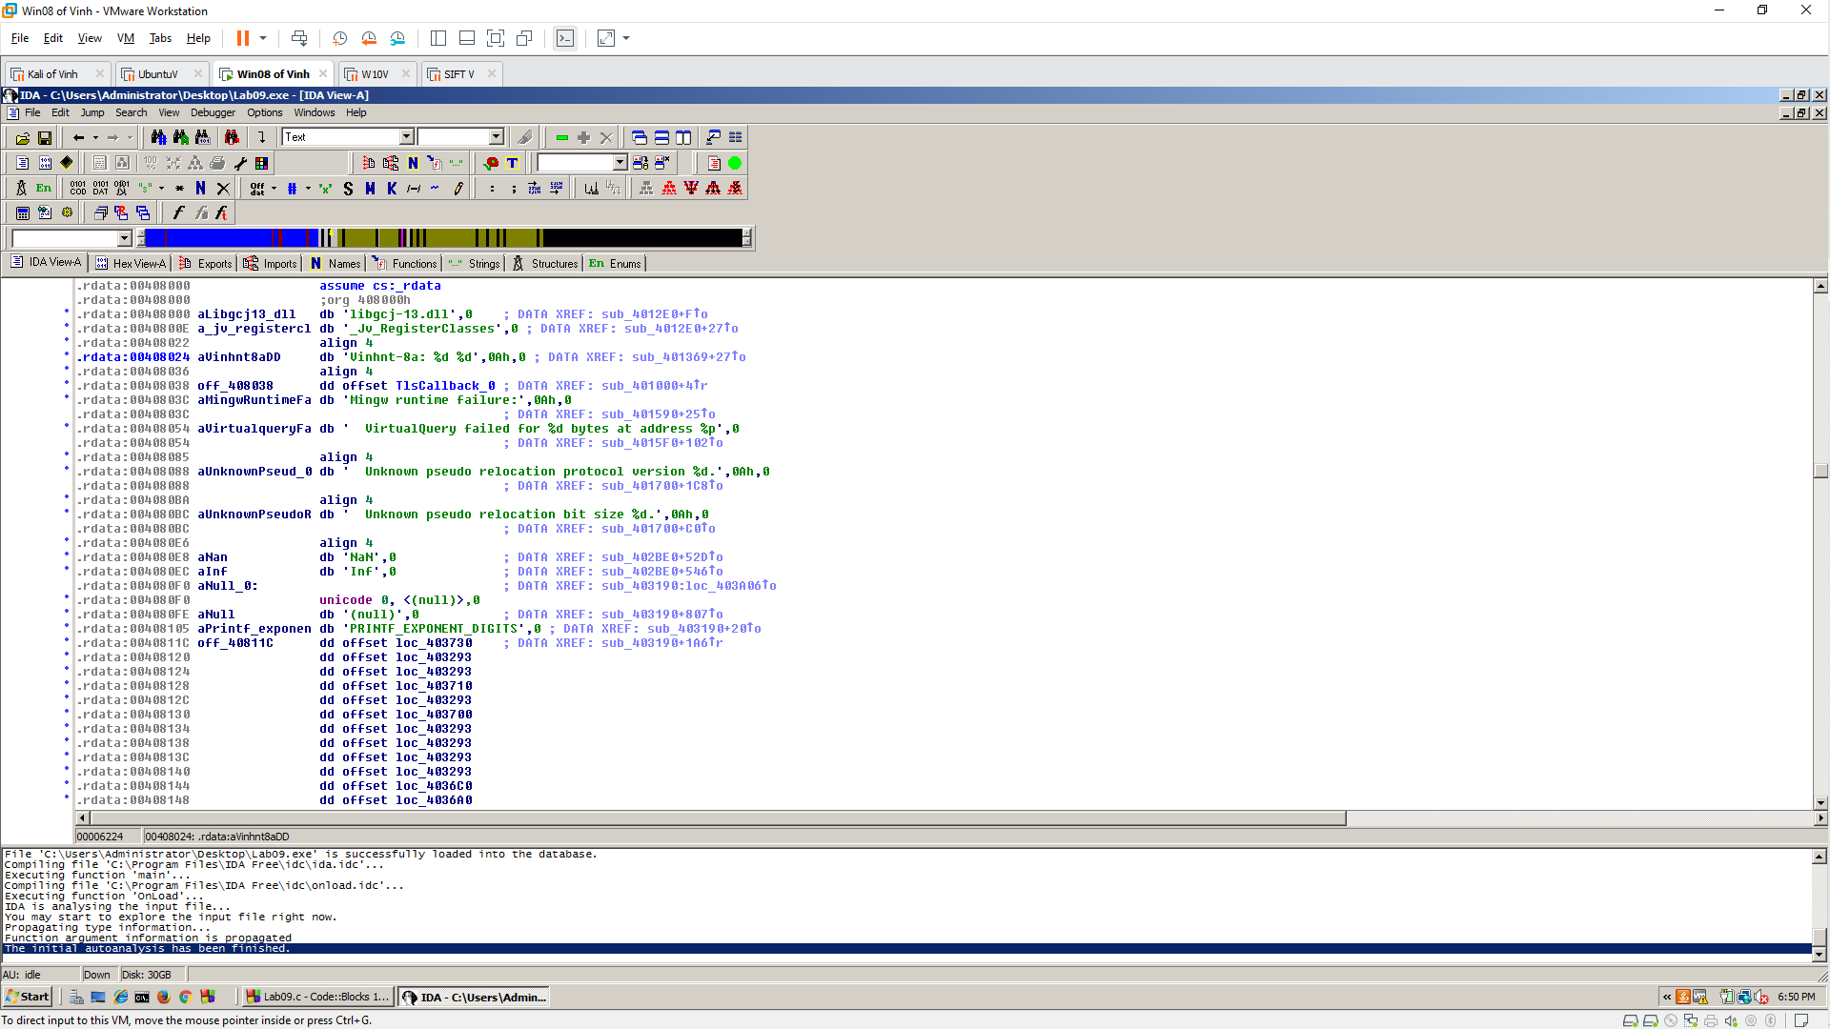
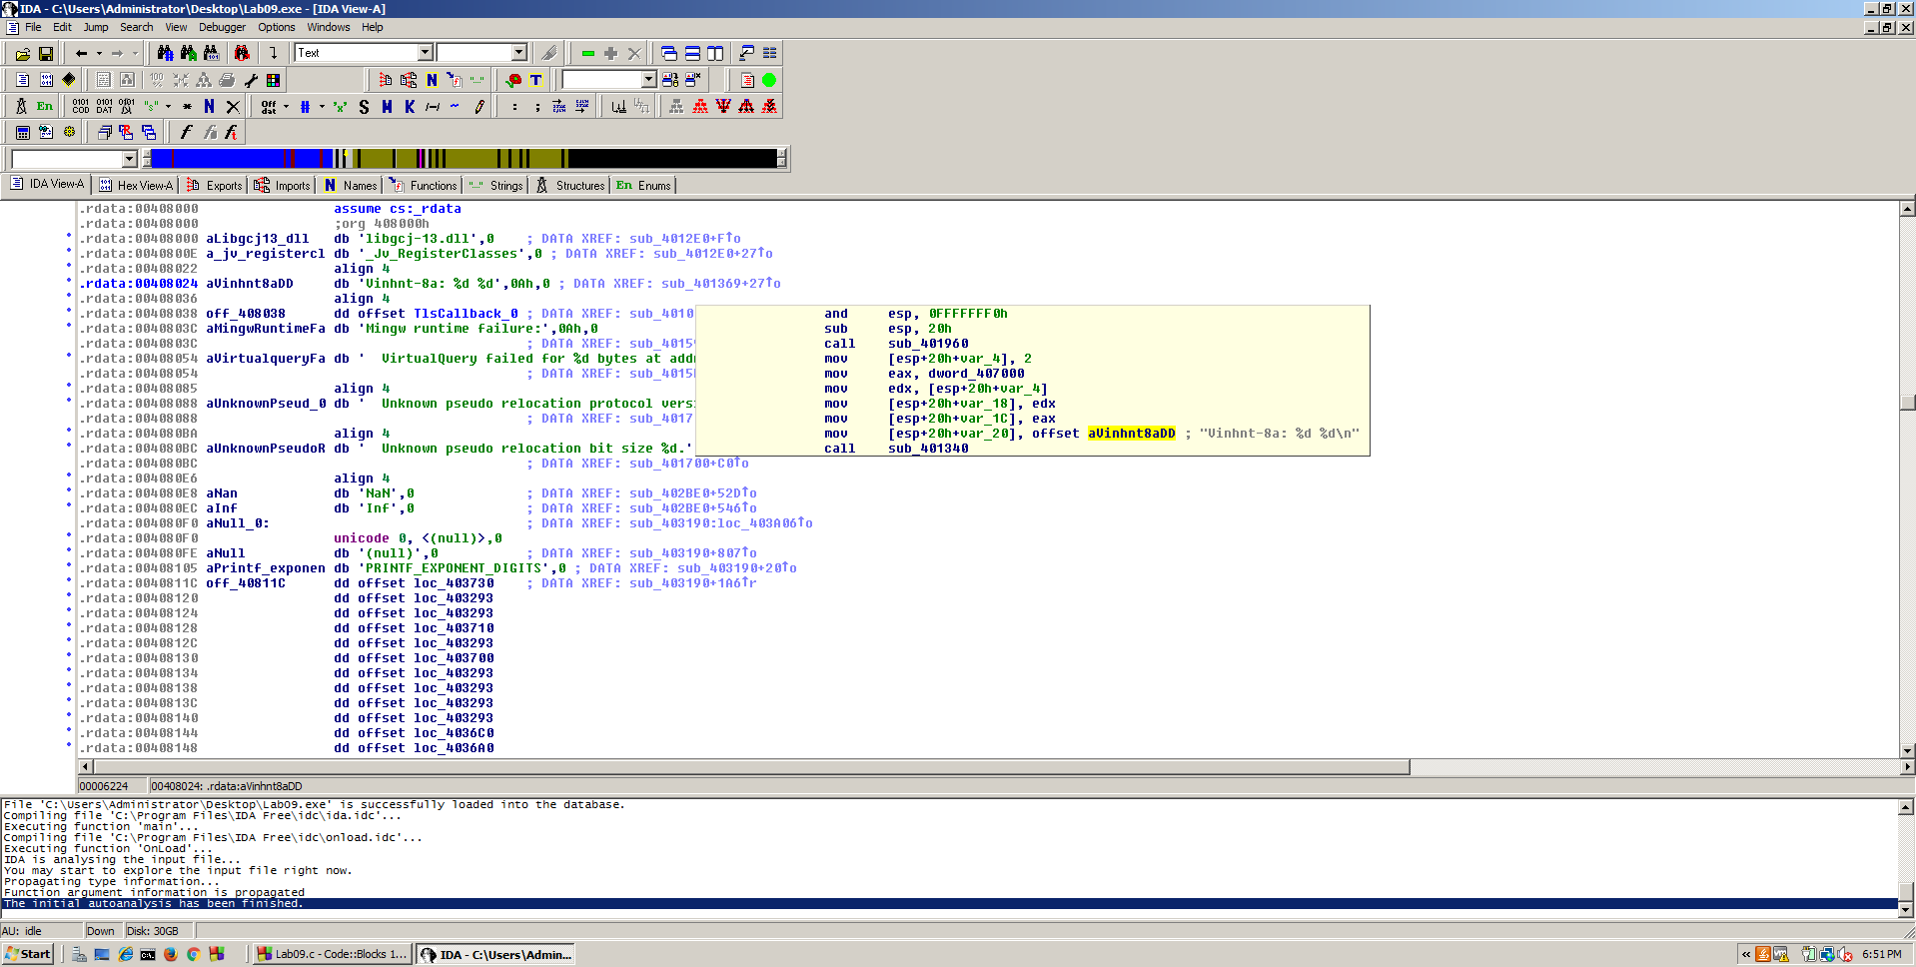
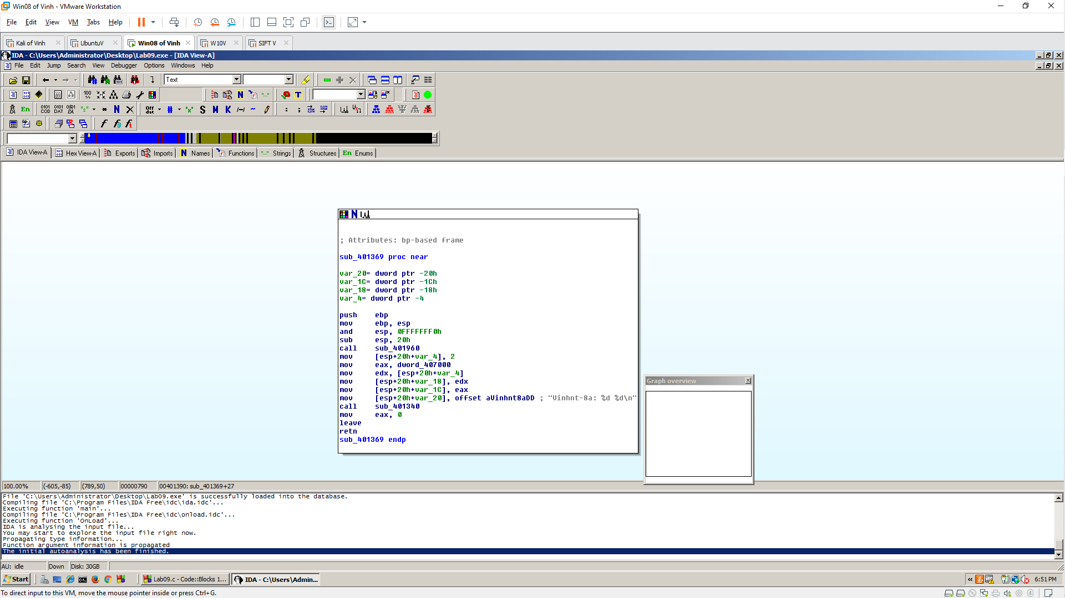
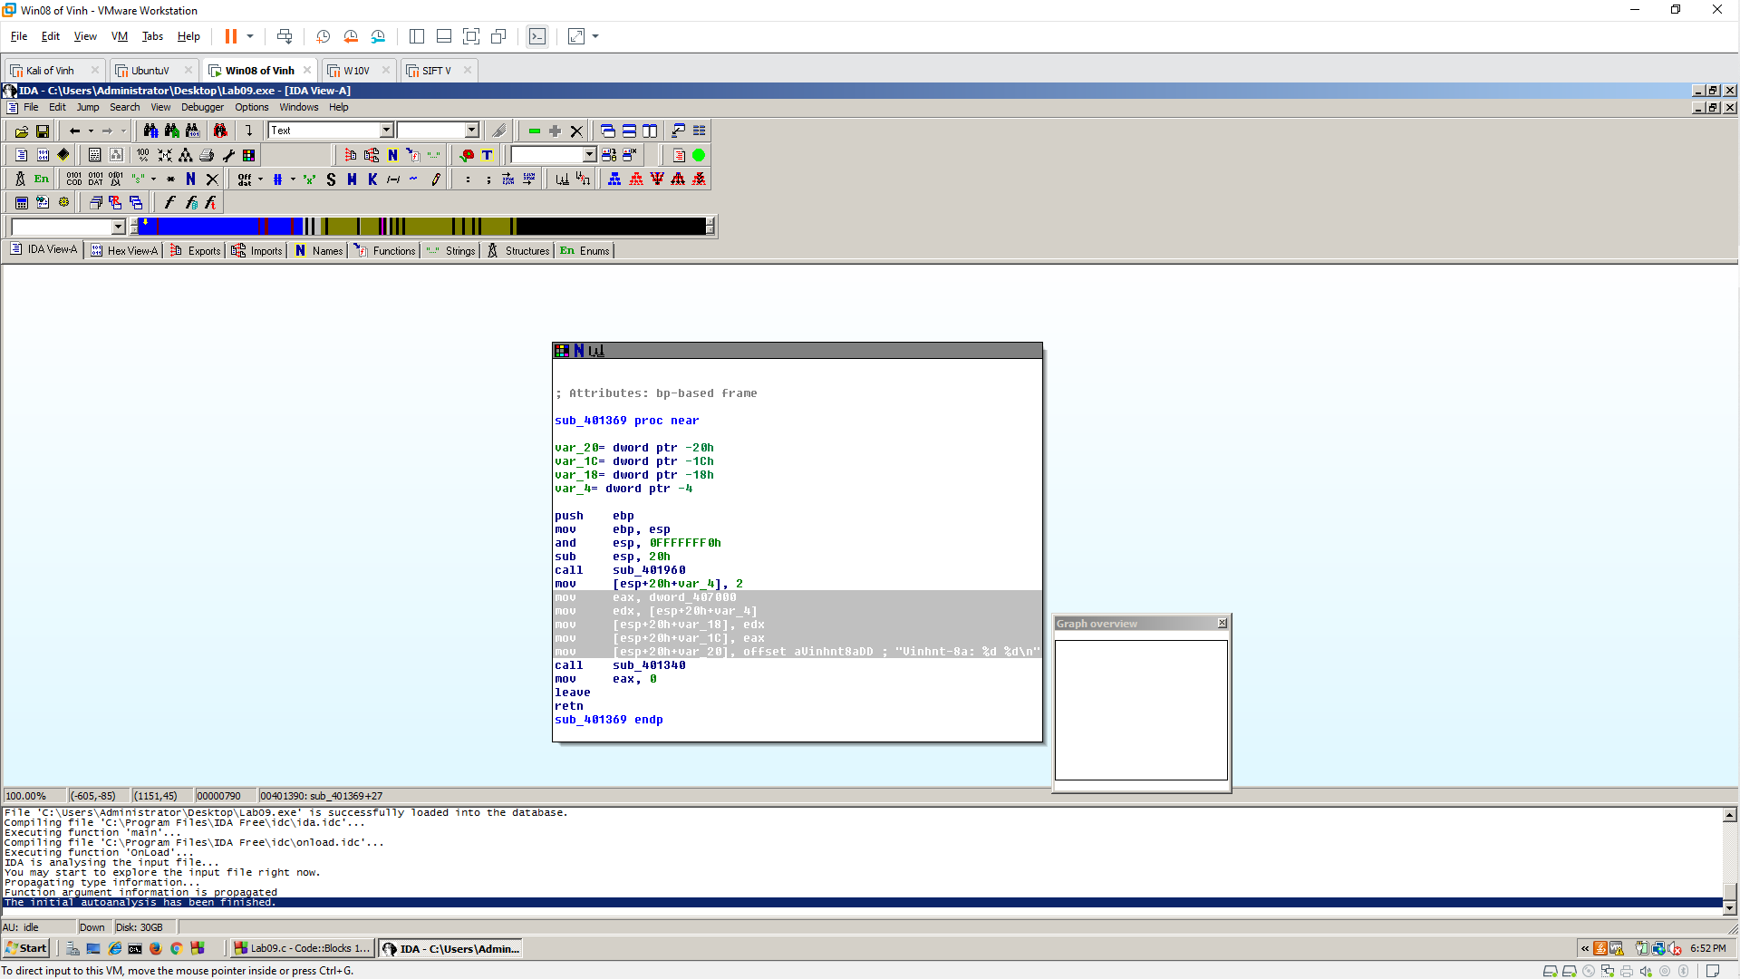
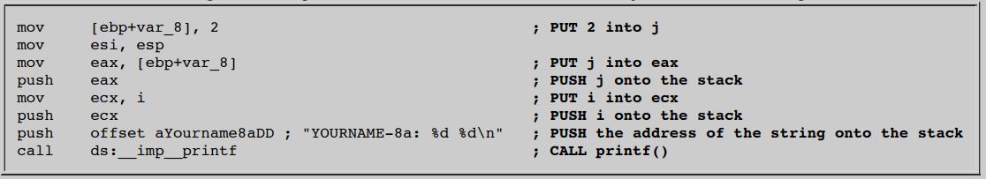

CHALLENGE: 10 Pts. Extra Credit
